 | Summer Food Service Program  New Programs  CNP Web Claim Tutorial  Program Year 2014 | Child Nutrition Services  Teaching and Learning Support  801 West 10th Street, Suite 200  P.O. Box 110500  Juneau, Alaska 99811-0500  Phone (907) 465-4788  Fax (907) 465-8910

Please note, our database is frequently modified by our contractor so the screen prints that you see in this tutorial may not match exactly what you see on your screen. If you have questions you may contact the State Agency (SA) Child Nutrition Programs (CNP) for guidance.

Bookmark the following URL address for EED Child Nutrition Programs webpage: – http://education.alaska.gov/tls/cnp/

Use this to access the CNP Web Login in right hand column

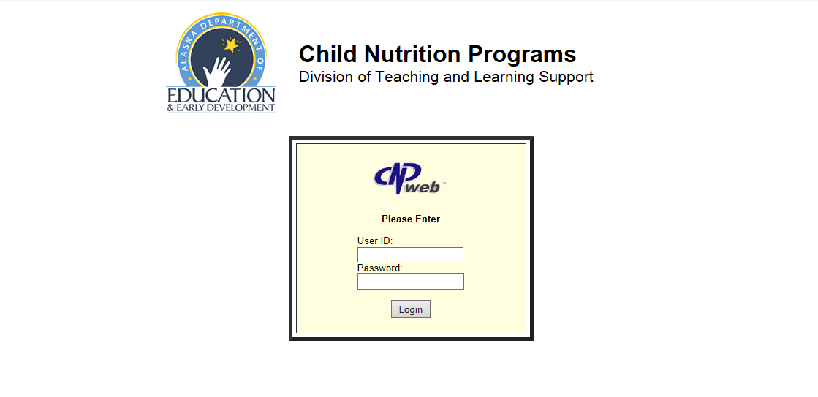 | Type in your User ID and Password that has been provided by the state agency (SA).  You’ll send a new CNP User Authorization Request each year in order to be given access to the CNP Web.

Click on the blue puzzle piece to enter the SFSP Database
Once your Sponsor and Site Applications have been approved you will be able to begin claiming on the CNP Web.

Once you have gained access to the CNP Web click the “Claims” tab. All months you are able to claim for will be available. Click the “add” button to begin adding your claim for a particular month.

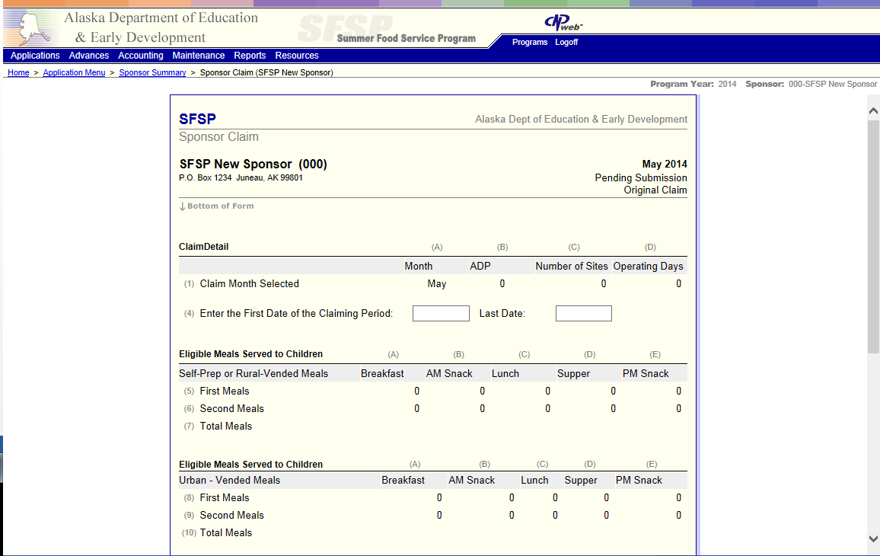 | You will be automatically directed to the Sponsor Claim.

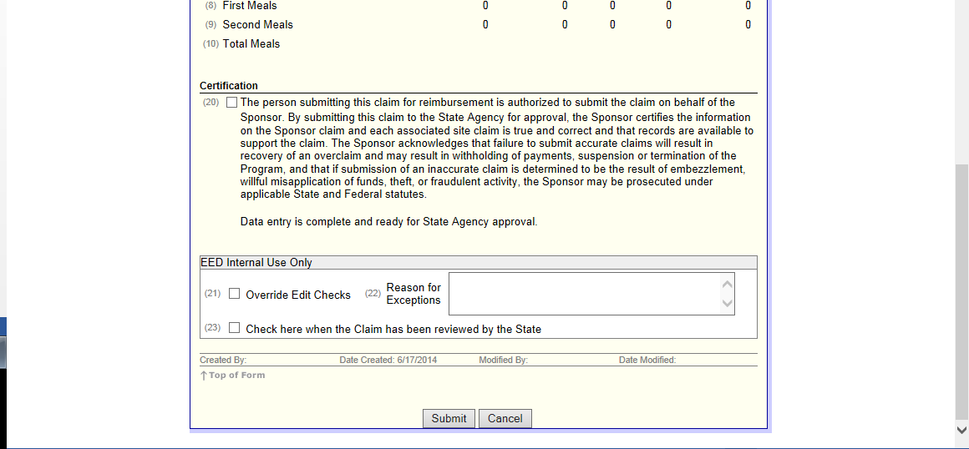 | Scroll to the bottom of your sponsor claim. You will not be able to enter anything, just hit the submit button at the bottom. Your sponsor claim will be in pending submission until your individual site claim(s) are complete.
Click here to maximize site claims  Click the “add” button to begin entering your site claim | This will take you back to the main claim tabs, but all of your site claims will now be available to add.  If the site claims have not already been listed out you will click the folder plus button on the left side of the claim month. This will drop down all of your site claims and you will have access to the site claim. Clicking the “add” button will allow you to begin entering your site claim.
Operating days go here.  Meal counts go here. | Enter the number of operating days for the claiming month.  You will enter your meal counts in the boxes A-E under “Meal Count Data”
 | When you are done entering your meal counts and site information. Click “submit”

Click here to edit | You will be directed back to the claims page. If you have no errors your sponsor claim will be in “Pending Submission”  Your Sponsor claim needs to be in Pending Approval in order to be processed by the State Agency. Click the “edit” button on the right hand side of your Sponsor Claim.
You will be directed to your Sponsor Claim. All of the information from your Center Claim(s) will carry forward to your Sponsor Claim.
You will want to enter your claiming start and end dates on line 4.

Submit here  Certify Claim here | Scroll to the very bottom of your Sponsor Claim. Check the Sponsor Certification box (box 20) and then click the “submit” button. This will push your claim into Pending Approval status.
Clicking submit will take you to your Claim Summary. You have successfully completed your first claim! You may want to print this for your files.

If you click “here” (circled in red) it will direct you back to the claim summaries tab.
 | Claim summaries tab.

