 | Child & Adult Care Food Program  Central Contractor Registry Registration  FY 2013 | Child Nutrition Programs  Teaching and Learning Support  801 West 10th Street, Suite 200  P.O. Box 110500  Juneau, Alaska 99811-0500  Phone (907) 465-8711  Fax (907) 465-8910

BACKGROUND:
The Federal Government is now requiring that ALL recipients receiving $25,000 or more of federal funding register with the Central Contractor Registry (CCR). Registrants are required to complete a one-time registration to provide basic information relevant to procurement and financial transactions. Registrants must update or renew their registration at least once per year to maintain an active status. CCR validates the registrant information and electronically shares the secure and encrypted data with the federal agencies finance offices to facilitate paperless payments through electronic funds transfer (EFT).

The CCR was originally established to improve the effectiveness and performance of Federal financial assistance programs, simplify Federal assistance application and reporting requirements, improve the delivery of services to the public, and facilitate greater coordination among those responsible for delivering the services.

The CCR has recently undergone some changes, and is now coupled into the SAM (System for Award Management) Database. This Database consolidates Federal procurement systems and the Catalog of Federal Domestic Assistance. Your CCR Registration should be conducted through the SAM Website: https://www.sam.gov/portal/public/SAM/

WHAT DATA IS NEEDED TO REGISTER IN CCR?
CCR registrants are required to submit detailed information on their company in various categories. Categories of required requested information include:

- General Information- Includes, but is not limited to, DUNS (Data Universal Numbering System) number, CAGE Code, company name, Federal Tax Identification Number, location, receipts, employee numbers, and web site address.
- Corporate Information- Includes, but is not limited to, organization or business type and SBA-defined socioeconomic characteristics.
- Goods and Services Information-Includes, but is not limited to, NAICS code, Product Service Code (PSC), and Federal Supply Classification (FSC) code.
- Financial Information- Includes, but is not limited to, financial institution, American banking Association (ABA) routing number, account number, remittance address, lock box number, automated clearing house (ACH) information, and credit card information.
- Point of Contact (POC) Information- Includes, but is not limited to, the primary and alternate points of contact and the electronic business, past performance, and government points of contact.

**Users will be unable to submit their registration online unless all mandatory information is provided. Please familiarize yourself with the CCR User’s Guide to complete this process

OBTAINING A DUNS NUMBER:
A DUNS number is a unique, non-indicative 9-digit identifier issued and maintained by D&B (Dunn & Bradstreet) that verifies the existence of a business entity globally. D&B assigns DUNS numbers for each physical location of a business. All U.S. Government contractors globally can receive a DUNS number at no charge and, under normal circumstances, within 1-2 business days when using the D&B web form process. If requested by phone, a DUNS can usually be provided immediately. Please visit http://fedgov.dnb.com/webform to request a DUNS number, or to find your existing DUNS.

HOW DO I REGISTER IN CCR?

Step 1: Access the CCR online registration through the SAM Webpage https://www.sam.gov/portal/public/SAM/.

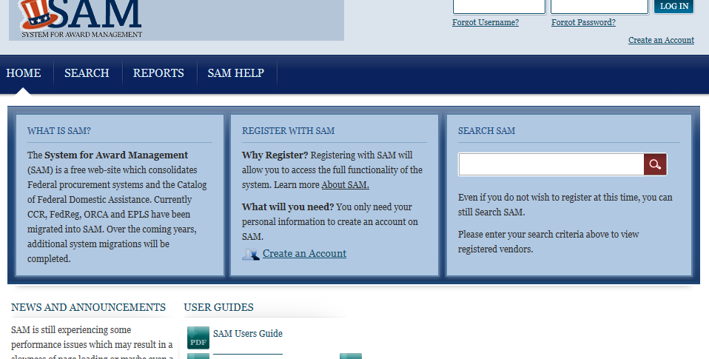 | Click on “Create an Account”  This will take you through the new account set-up step-by-step.

Step 2: By clicking “Create an Account” you will be walked through the registration process by the SAM system.

Step 3: Once you have created your SAM account you will then be able to either transfer your current CCR information, or register a new entity within the CCR system.

3a. If you need to transfer your current CCR information and renew the registration click the “YES” button at the top of your screen.

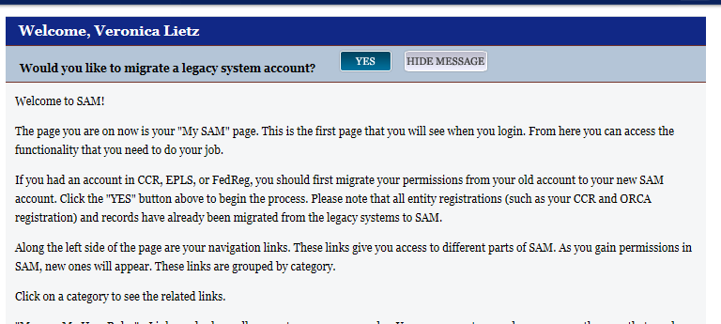

3b. If you are registering with the CCR for the first time, you will click the “Manage Entity” tab on the far right-hand side of your screen. The option to “Register New Entity” will appear, click that and it will guide you through the CCR Registration process.

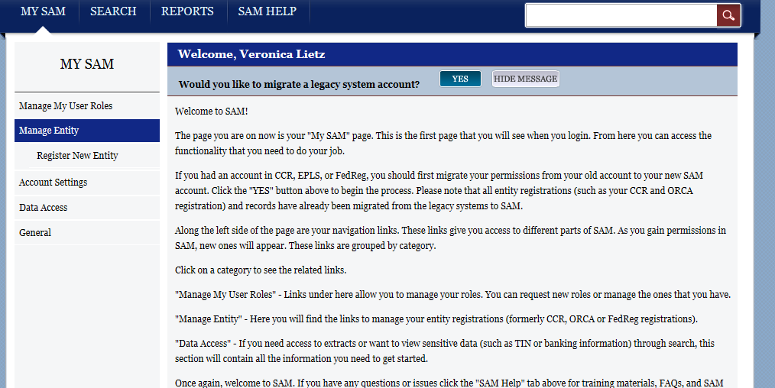

Step 4: Once you have completed the SAM and CCR Registration please complete the attached Alaska Department of Education & Early Development 2012-2013 Assurances form. You will need your DUNS number and CCR Registration Expiration. Send the completed Assurance form back to Child Nutrition Programs with your annual update/renewal documents.

