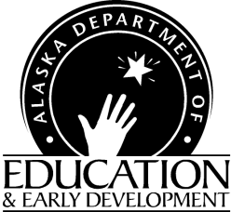
CHILD AND ADULT CARE FOOD PROGRAM

Bulletin
DEED CACFP Bulletin Web Page
Child Nutrition Programs
Finance & Support Services
801 West 10th Street, Suite 200
PO 110500
Juneau, Alaska 99811-0500
(907) 465-8711
Fax: 907 465-8910
Ann-Marie Martin

To: CACFP Sponsors and Institutions Date: September 3, 2019

From: Ann-Marie Martin, CACFP Program Coordinator Bulletin: 2019-05

Sponsoring organizations and institutions are required, by regulation, to keep Bulletins, Instructions, and USDA Policy Memorandums for reference and to apply immediately the appropriate instruction to agency programs. Contact Child Nutrition Programs if you need further clarification.

Policy Memos that have been posted on the CNP Database Welcome Page:
- CACFP 14-2019 - Farm Bill Implementation Memo: Donated Traditional Foods and Civil Liability
- CACFP 15-2019 - Crediting Coconut, Hominy, Corn Masa, and Masa Harina in the CNP.

Additional Topics
- USDA Program Reimbursement Rates July 1, 2019-June 30, 2020
- USDA Non-Discrimination Statement
- Webinar: Using the Nondiscrimnation Statement in the Child Nutrition Programs: Where, When, Why, and How?
- USDA Meal Pattern Training Slides Now Available!
- USDA Feeding Infants in the CACFP Handbook revised

Resources
- Institute of Child Nutrition (ICN) Mealtime Memo
- WIC Breastfeeding Support Learn Together. Grow Together
- USDA Meal Pattern Training Worksheets
- Institute of Child Nutrition (ICN) Meal Pattern on one sheet
- Updated Food Buying Guide
- Listserv

USDA Policy, Information & Implementation Memos

- CACFP 14-2019 Farm Bill Implementation Memo: Donated Traditional Foods and Civil Liability
The purpose of this memorandum is to notify child nutrition program operators of the 2018 Farm Bill’s expansion of the provision stating that certain groups are not liable in civil cases regarding the donation and service of traditional foods. This provision only applies to food service programs at public and nonprofit facilities that primarily serve Indians, including those operated by Indian Tribes and Tribal organizations. The 2018 Farm Bill expanded the elimination of civil liability to additional organizations and persons (as described above) and added the “storage” and “preparation” of donated traditional foods to the list of activities covered by the provision.
- CACFP 15-2019 Crediting Coconut, Hominy, Con Masa, and Masa Harina in the Child Nutrition Programs
This memorandum rescinds and replaces SP 22-2019, CACFP 09-2019, SFSP 08-2019 Crediting Coconut, Hominy, Corn Masa, and Corn Flour in the Child Nutrition Programs. This updated memorandum provides guidance on crediting coconut (including dried coconut), hominy, corn masa, and masa harina and clarifies how to identify popular products made from corn that can credit towards the grain requirements.

Additional Topics

- USDA Program Reimbursement Rates July 1, 2019-June 30, 2020

Child and Adult Care Centers
Eligibility | Breakfast | Lunch/Supper | Snack
Paid | 0.47 | 0.53 | 0.13
Reduced Price | 2.65 | 5.14 | 0.76
Free | 2.95 | 5.54 | 1.52
This reimbursement rate for Cash In-Lieu of Commodities is 23.75 cents for lunch/suppers

Family Day Care Homes
Tier | Breakfast | Lunch/Supper | Snack
Tier I | 2.12 | 4.04 | 1.20
Tier II | 0.75 | 2.44 | 0.33

Sponsoring Organizations of Day Care Homes
Number of Homes | 1-50 | 51-200 | 201-1000 | Over 1000
Administrative Rate | 194.00 | 148.00 | 115.00 | 102.00

- USDA Non-Discrimination Statement
USDA has revised the Non-Discrimination Poster, which changes the image from the Statue of Libery to the Capital Building. DEED has ordered posters and will send one out for each one of your sites as soon as they arrive. As a reminder from annual training, you are required to have one poster per site and it should be posted in a prominent location. You no longer are required to have one in each feeding area.
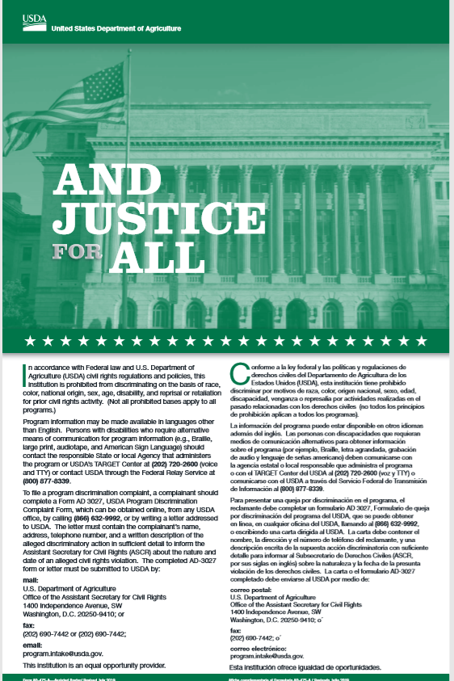

- Webinar: Using the Nondiscrimination Statement in the Child Nutrition Programs: Where, When, Why, and How?

You are invited to a Webinar!
Using the Nondiscrimination Statement in Child Nutrition Programs:
Where, When, Why, and How?
Monday September 16, 2019
9:00 AM Alaska Time
Title: Using the Nondiscrimination Statement in Child Nutrition Programs: Where, When, Why, and How?
Description: Each year thousands of Child Nutrition Programs applications, verification documents, and questions about lunch balances are sent in error to the Office of the Assistant Secretary for Civil Rights. These misdirected materials and questions slow down the review of applications for schools and childcare facilities and can cause confusion for families. This webinar will help State agencies and local Program operators learn where and when to use the appropriate Nondiscrimination Statement, as well as which version of the statement must be used to be compliant with Program regulations. The goal of this webinar is to improve customer service by clarifying the proper use of the Nondiscrimination Statement and clarify for families where to send completed applications, verification materials, and questions about account balances. We will provide several examples and answer questions at the end of the webinar.
Target Audience: State agencies and local Program operators.
To participate in the webinar on Monday, September 16th at 1:00 PM ET:
Please click on the link below to register. You may use the same link to log-in to participate on September 16th: Using the Nondiscrimination Statement in the Child Nutrition Programs Webinar (https://usda-fns.webex.com/usda-fns/onstage/g.php?MTID=e2db1aeba397aa5a8175c7a43cb6ca1ef)
Streaming audio will be available through your computer. If that is not an option, use the call-in information below. To receive a callback, provide your phone number when you join the event, or call the number below and enter the access code.
US Toll: +1-415-527-5035
Access code: 900 710 655
If you are unable to attend the LIVE webinar, there will be a recording of the webinar announced and posted on the PartnerWeb a few weeks after the webinar’s completion.
- CACFP Meal Pattern Training Slides Now Available!
The USDA’s Team Nutrition initiative is excited to announce the release of the CACFP Meal Pattern Training Slides. The slides may be downloaded at: CACFP Meal Pattern Training Slides. (https://www.fns.usda.gov/tn/meal-pattern-training-slides-cacfp). The following presentations are available in both English and Spanish:
- Choose Breakfast Cereals That Are Lower in Added Sugars
- Choose Yogurts That Are Lower in Added Sugars
- Serving Milk in the CACFP
- Meal Planning for the CACFP
- Serving Meat and Meat Alternates at Breakfast
- Offer Versus Serve in the CACFP
- Methods for Healthy Cooking
- Adding Whole Grains to Your CACFP Menu
- Feeding Infants: 0-5 months
- How to Support Breastfeeding in the CACFP
- Feeding Infants: Starting with Solids
Presentations are designed for interactive 30-minute trainings. Training worksheets that can be used with these slides are available for download at CACFP Meal Pattern Training Worksheets and may be requested as printed copies at: CACFP Meal Pattern Training Worksheet Printed Copies Request
- New Food Yields in the USDA Food Buying Guide!
New food yields for the following food items have been added to the Food Buying Guide for Child Nutrition Programs (FBG) Interactive Web-Based Tool: surimi seafood, tempeh, coconut, popcorn, and hominy. Please see the following memos for guidance on these newly creditable food items:
- SP 08-2019, CACFP 02-2019, SFSP 02-2019 Update of Food Crediting in the Child Nutrition Programs
- SP 22-2019, CACFP 09-2019, SFSP 08-2019 Crediting Coconut, Hominy, Corn Masa, and Corn Flour in the Child Nutrition Programs and SP 26-2019
- SP 23-2019, CACFP 10-2019, SFSP 09-2019 Crediting Popcorn in the Child Nutrition Programs
- SP 24-2019, CACFP 11-2019, SFSP 10-2019 Crediting Surimi Seafood in the Child Nutrition Programs
- SP 25-2019, CACFP 12-2019, SFSP 11-2019 Crediting Tempeh in the Child Nutrition Programs
Check out these new food items on the Food Buying Guide for Child Nutrition Programs Interactive Web-Based Tool and the FBG Mobile App.
Have you downloaded the FBG Mobile App? Check to ensure you have the most current version of the app on your mobile devices!

- USDA Feeding Infants in the CACFP Handbook
DEED provided each agency that has an infant feeding program this handbook. It may be a good idea to bookmark this on your computer or use the link to order more copies directly from USDA Team Nutrition: USDA Feeding Infants in the CACFP Handbook (https://www.fns.usda.gov/tn/feeding-infants-child-and-adult-care-food-program)
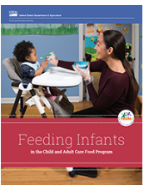

- CACFP Halftime Thirty on Thursdays Training Webinars.
Join USDA Team Nutrition for monthly training webinars on hot topics related to the CACFP Meal Pattern requirements on the third Thursday every other month (September). You must register ahead of time for the webinars. If you attend a webinar, you will receive a certificate. If you view the webinar afterwards through the website you will not receive a certificate. You can find more information by going to: CACFP Halftime Thirty on Thursdays (https://www.fns.usda.gov/cacfp-halftime-thirty-thursdays-training-webinar-series).

Resources

- Institute of Child Nutrition Mealtime Memo Under Educational Resources you can find monthly newsletters. You can use these as training topics for your staff and/or include with parent information. The March Mealtime Memo focuses on the importance of Breakfast.

- WIC Breastfeeding Support Learn Together. Grow Together
FNS has launched a new breastfeeding campaign, WIC Breastfeeding Support Learn Together. Grow Together. Campaign materials can be found at WIC Breastfeeding Support website geared towards WIC moms.
Family and friends will find resources on the WIC website, including videos from real dads and grandparents, to learn more about breastfeeding and how they can support mom and baby on their breastfeeding journey.
Likewise, WIC partners and staff can access resources on the site to download, print and share with moms to help them meet their breastfeeding goals. Some resources, such as Grow and Glow in WIC, are now available on the WIC Works Resource System.
- USDA CACFP Crediting Webinar Recordings: Be in the Know! Webinar Series

  - Guidance on Dried Meat Products
  - Additional Meat/Meat Alternate Options – Tempeh and Surimi:
  - Crediting Vegetable Noodles and Coconut

- USDA Halftime Thursdays Webinar
  - Link to USDA Halftime Thursdays Webinar

- Institute of Child Nutrition (ICN) Meal Pattern on one sheet
ICN has created a one-page sheet for the new child or adult meal patterns. If you would like a one-sheet meal pattern you can get through the ICN website under Child Nutrition Resources.

- Updated Food Buying Guide USDA has released the updated Food Buying Guide to help nutrition staff understand number of portions when purchasing foods. You can download the Food Buying Guide.

- Listserv- Did You Know? Alaska Child Nutrition Programs has a listserv. The purpose of the listserv is to provide information and updates on the USDA Child Nutrition Programs, including the National School Lunch Program, the Child and Adult Care Food Program, and the Summer Food Service Program. To receive all of the hottest news and updates from Alaska Child Nutrition Programs, subscribe at Alaska Child Nutrition Programs ListServ. You will receive a confirmation link via email, and you should click to complete your subscription.

Contact information
Ann-Marie Martin, Program Coordinator
(907) 465-8711 fax (907) 465-8910
Ann-Marie Martin (annmarie.martin@alaska.gov)

Dan Hysell, Education Program Assistant
(907) 465-4969 fax (907) 465-8910
Dan Hysell (dan.hysell@alaska.gov)

Commonly Used Acronyms
CACFP – Child and Adult Care Food Program
CNP – Child Nutrition Programs
FNS – Food & Nutrition Services
FNSRO – Food & Nut Reg. Office
USDA – US Department of Agriculture
LEA – Local Education Authority
DEC – Dept. of Environmental Conservation

This institution is an equal opportunity provider.

