ASSESS, CREATE & MONITOR ACCESSED IN THE SUCCESS CYCLE LINK
It’ all on one web page!!

ASSESS AN INDICATOR 1.) Go to Success Cycle 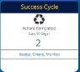 on the Home Page and click on Assess, Create, Monitor (or go to the Assess, Create, Monitor via the gray Main Menu bar.) 2.) Choose an indicator and follow the prompts: Fill in the bubbles, describe implementation efforts by putting todays date and description. The text field will expand with historical data. 3.) Click save .
ASSESS

CREATE AN OBJECTIVE 1.) Go to Success Cycle on the Home Page and click on Assess, Create, Monitor (or go to the Assess, Create, Monitor via the gray Main Menu bar.) 2.) Choose an indicator and scroll down to “Create & Monitor” and follow the prompts: assign a team member, establish a date and describe how it will look when objective is fully met. 4.) Start with today’s date and then write a description of fully met: this is the Objective/Goal. 5.) Click save .
CREATE
ADD AN ACTION 1.) Continue down the page to the button (or starting at the home page, go to Success Cycle Assess, Create Monitor, click on the indicator and scroll down to add an action by clicking on the button. 2.) Follow prompts to fill fields and save .

MONITOR THE PLAN 1.) Go to Success Cycle 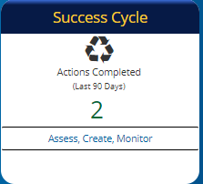 2.) Choose a previously assessed indicator that has an objective and action(s). 3.) Scroll down to the bottom of the page to “Create & Monitor” and, if needed, change the info in the fields. 4.) Click on the “Completed” field to add a date of completed action. Or click on the action to modify an action in the pop-up window and click save 5.) Once a completion date is entered, decide on “Objectives Status” in the pop-up window. 6.) Follow prompts in the next window 7.) Click save
MONITOR

If an indicator is not viewable, it must be selected in the “Our Direction” links.
1.) Go to Our Direction 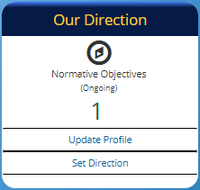 on the Home Page and click on Set Direction 2.) Click on Indicator Selection: 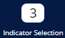. 3.) Click on a Domain with the Indicator to assess. 4.) Check the indicator to be assessed. 5.) Click on the “View Selected Indicators”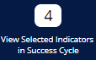. 6.) You are now back in the Success Cycle.

